THE USES OF DEMOGRAPHIC DATA:

A significant challenge for advocates is the lack of available demographic information about who lives in manufactured home communities. This data can be a critical tool for advocates because through data it is possible to challenge the inaccurate preconceived notions about manufactured home communities that are shared by both policy makers and members of the general public. The conception that people who live in manufactured housing are transient, for example, is easily dispelled with solid statistical analysis. By combining personal stories with compelling data, a full picture can emerge of manufactured home communities. This can be a powerful tool in efforts to change public policy, as well as a vital component in the struggle to shift public opinion about this vital affordable housing resource.

COMPILE A LIST OF PARKS:

Compiling demographic data on manufactured housing communities is complicated by the fact that the census data does not differentiate between manufactured housing that is privately sited and that which is sited in parks. Our interest is only in the latter. Because the census does not make this differentiation, it is necessary to have as complete of a list of parks as possible before beginning to manipulate the census data. We can’t stress this step enough!

Some states have some means of licensing or otherwise tracking manufactured home communities. If your state is one of these, then you’re in luck. If not, then one place to start is:

http://www.mobilehomeparkstore.com/list.htm.

We don’t make any guarantees as to the completeness or accuracy of this information, but if nothing else it’s a jumping off point. The most important information you need to gather is number of lots, city, and county. To find county names, use the website:

http://www.naco.org/Template.cfm?Section=Data_and_Demographics&Template=/cffiles/counties/city_srch.cfm.

To find zip codes, you can use the website:

http://zip4.usps.com/zip4/citytown.jsp.

Make your list in the “Complete Park List” tab of the Protocol Template provided.

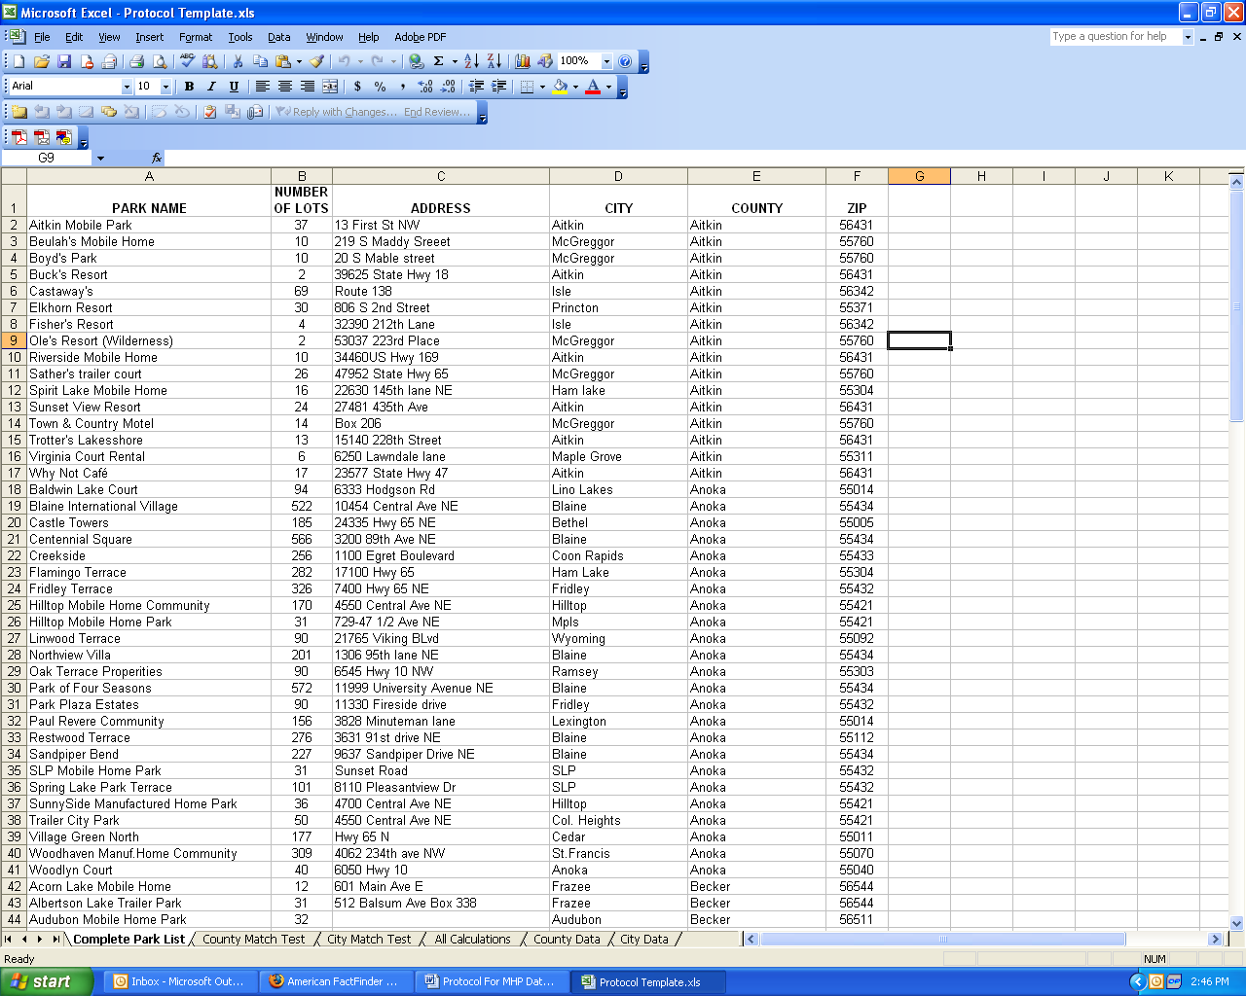

TEST COUNTY MATCHES:

1) Count how many known units exist in each county. One way to do this is to sort your master list alphabetically by county, and then use the sum function. Place your totals and the corresponding county name in the first two columns of the “County Match Test” tab of your spreadsheet.

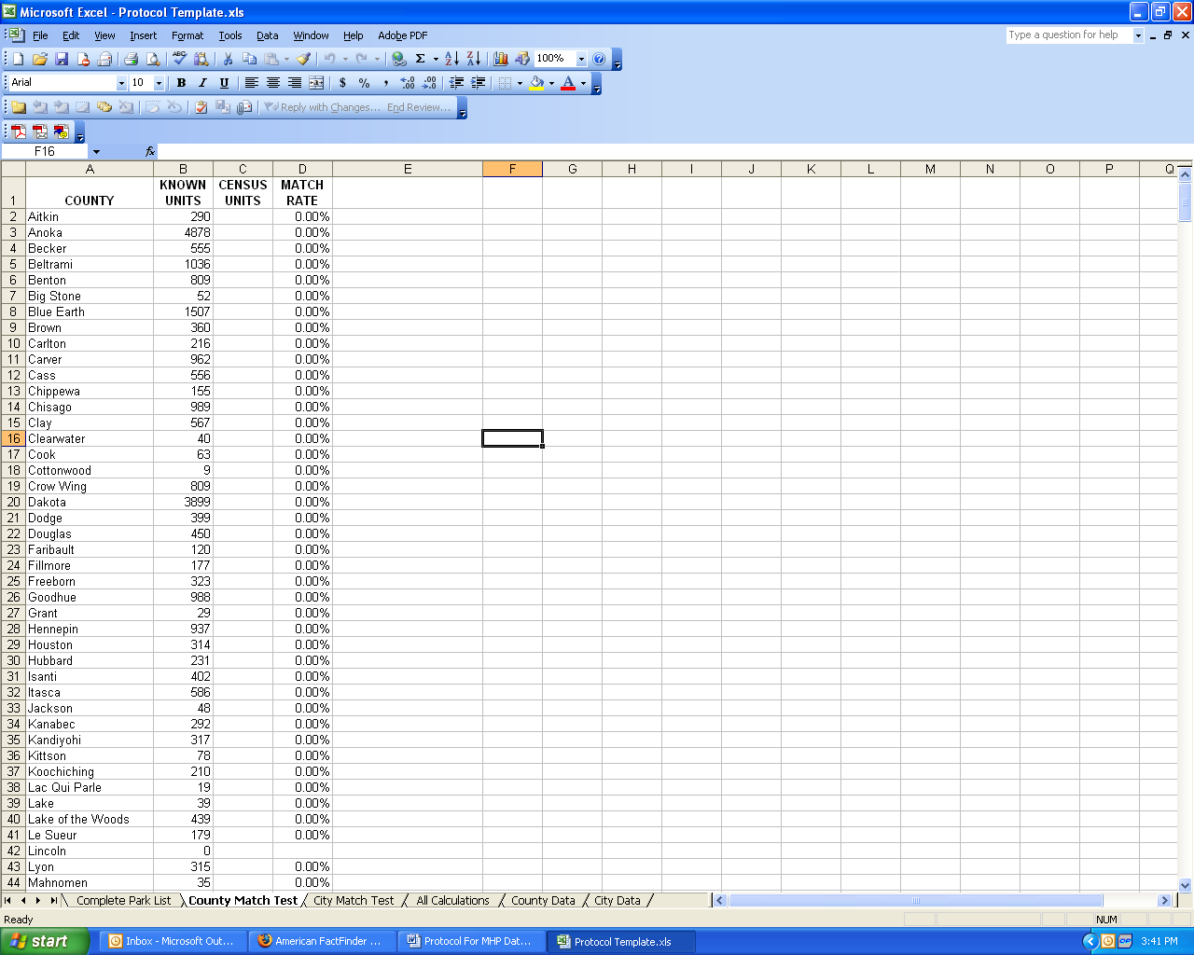

2) All census numbers dealing with manufactured homes come from Summary File 3 of the 2000 Census, which can be accessed online at:

http://factfinder.census.gov/servlet/DTGeoSearchByListServlet?ds_name=DEC_2000_SF3_U&_lang=en&_ts=147707767812.

Go to this website and under “Select a geographic type” choose “County.” The website will then prompt you to select a state. After you select your state, the website will generate a list of counties. Select all the counties that contain manufactured home parks, and then click the “Add” button. To select multiple counties at once, hold down the Control key while highlighting the counties you want. When you’re done making your selection, and all of the counties appear in the “Current geography selections” box at the bottom of the webpage, click “Next.”

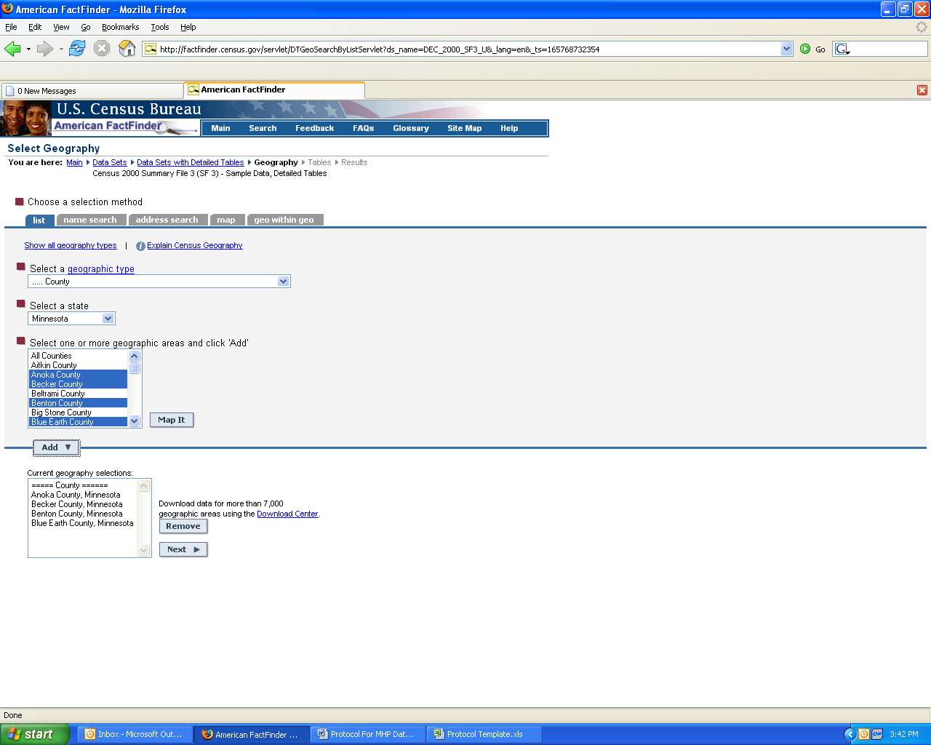

3) Select the following tables, and click “Add,” then “Show Result”:

H30. Units in Structure
H31. Units in Structure for Vacant Housing Units

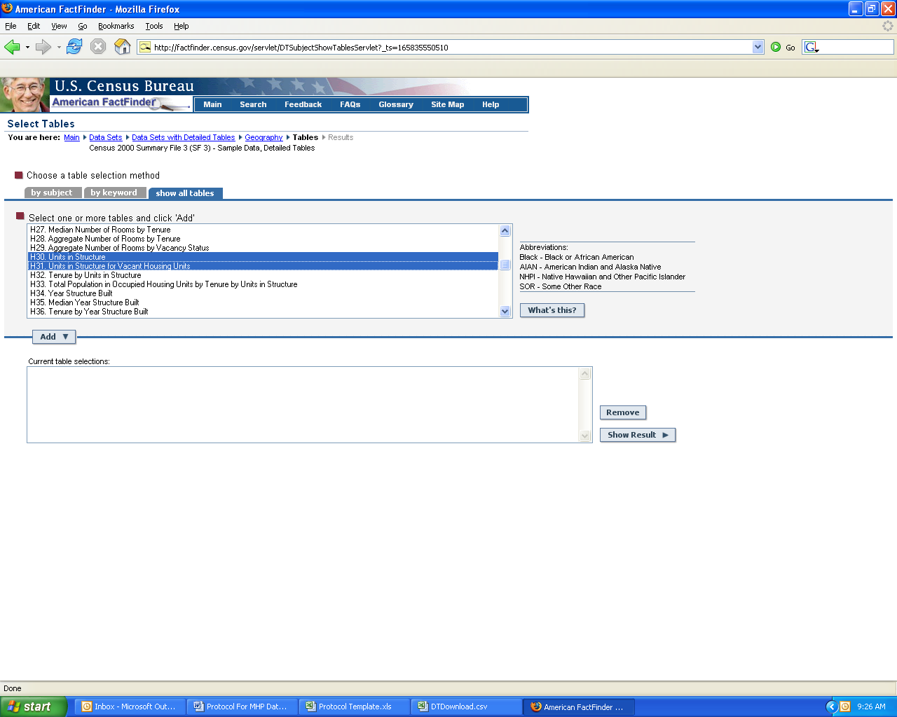

4) Go up to “Print/Download” tab and select “Download” from the drop-down menu.

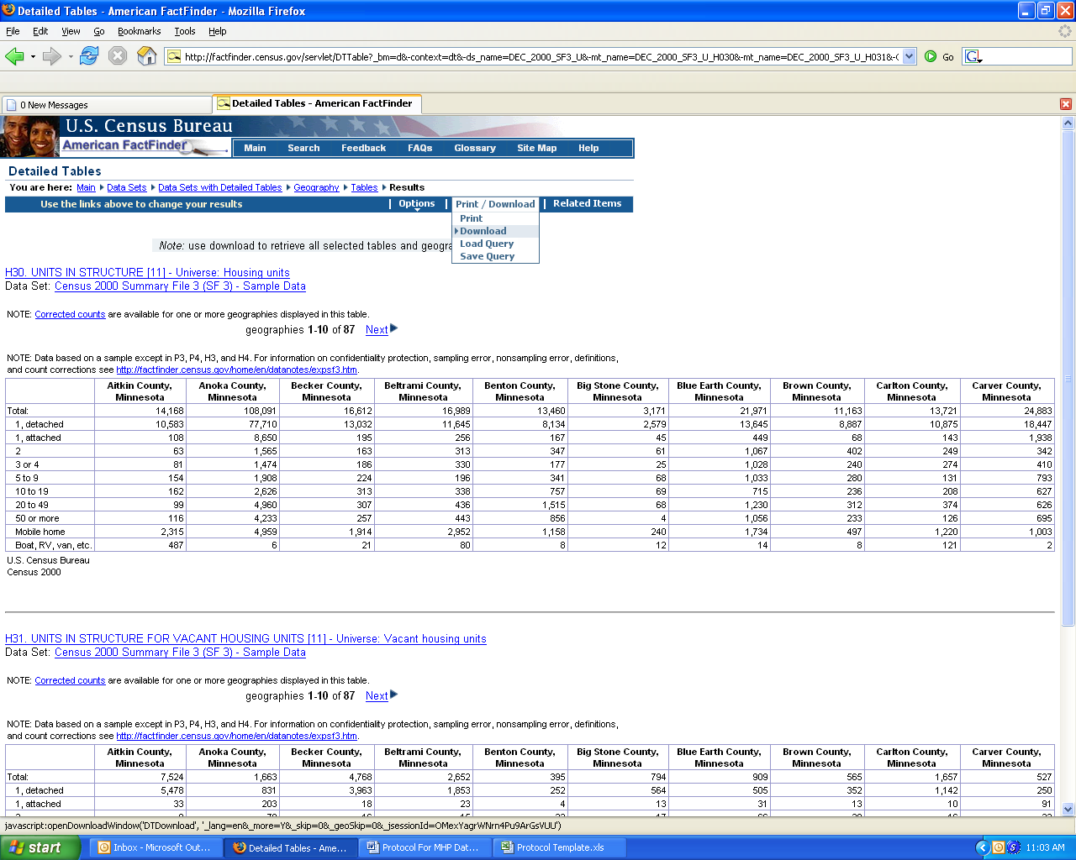

5) Select the second option on the list, “Comma delimited (.csv) (transpose rows and columns)” and then click “Ok.” Your downloaded file will be called DTDownload.csv.

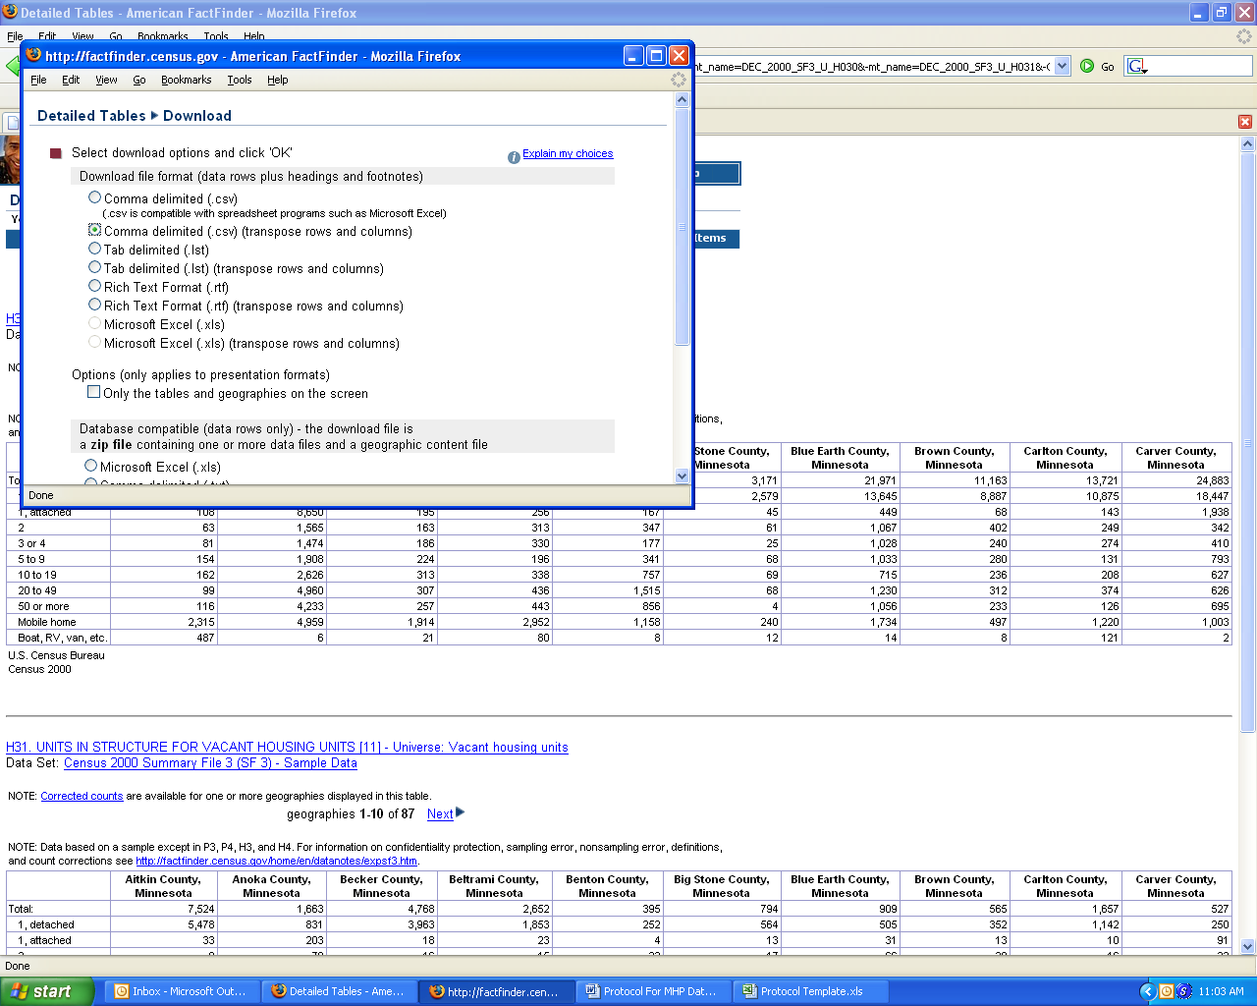

6) Open the file you just downloaded. You’ll notice that the counties appear in alphabetical order. Check that the order of this list matches the order of your list. If not, rearrange your list to make them match up. Once this is done, copy the values in Table H30 under the column “Mobile home” and paste them into the “Total Census Units” column in the “County Match Test” spreadsheet. Then copy the values in Table H31 under the column “Mobile home” and paste them into the “Vacant Census Units” column in the “County Match Test” spreadsheet.

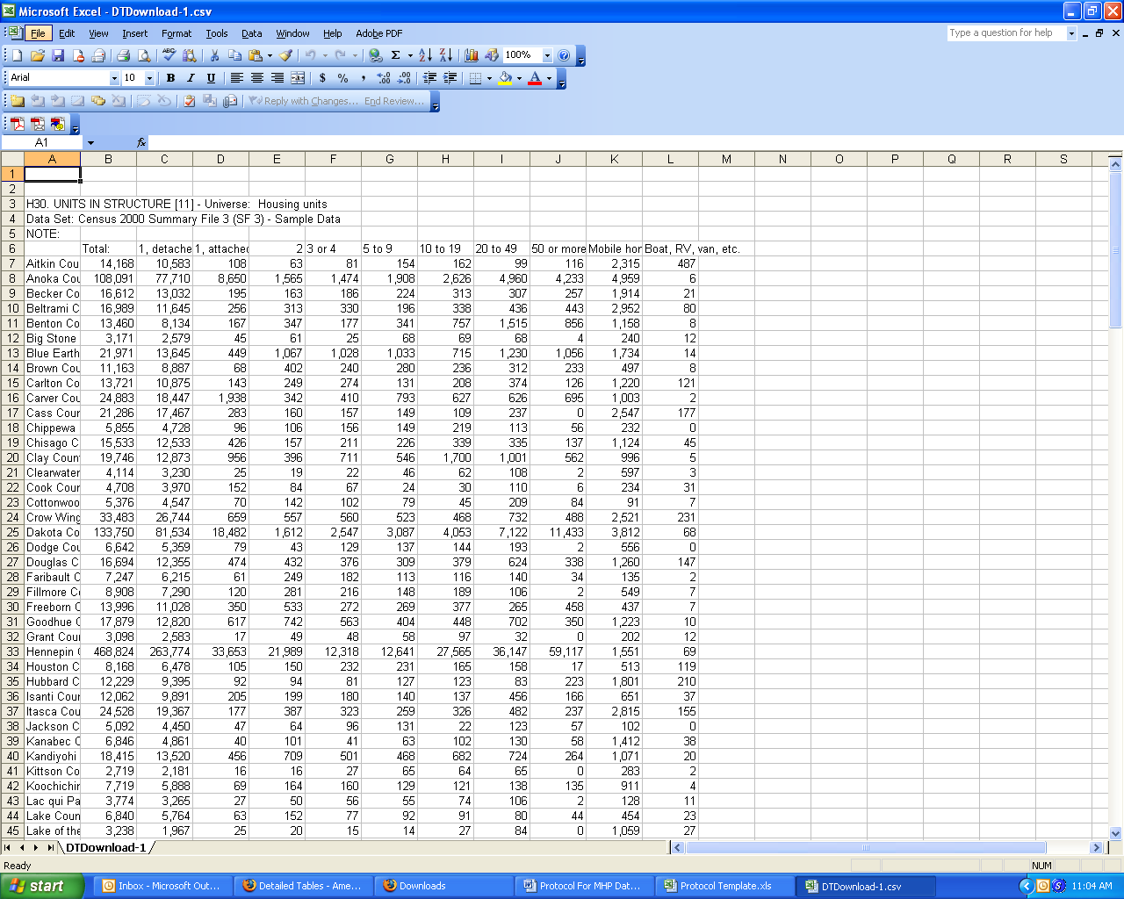

7) The template will automatically calculate the “Match Rate” column for you. Note that ALL yellow columns throughout the template will automatically calculate. Click in the upper right hand box (the one to the left of “A” and above “1” to select your entire chart. The go up to “Data” and select “Sort” from the dropdown menu.

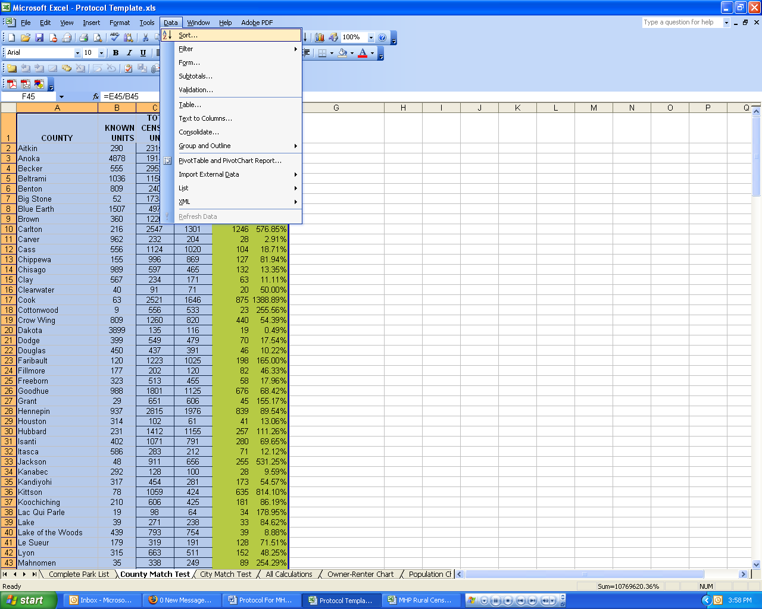

8) Under “Sort by” option, select “MATCH RATE.” If this is not an option, make sure that below you have chosen to have a header row. Click OK.

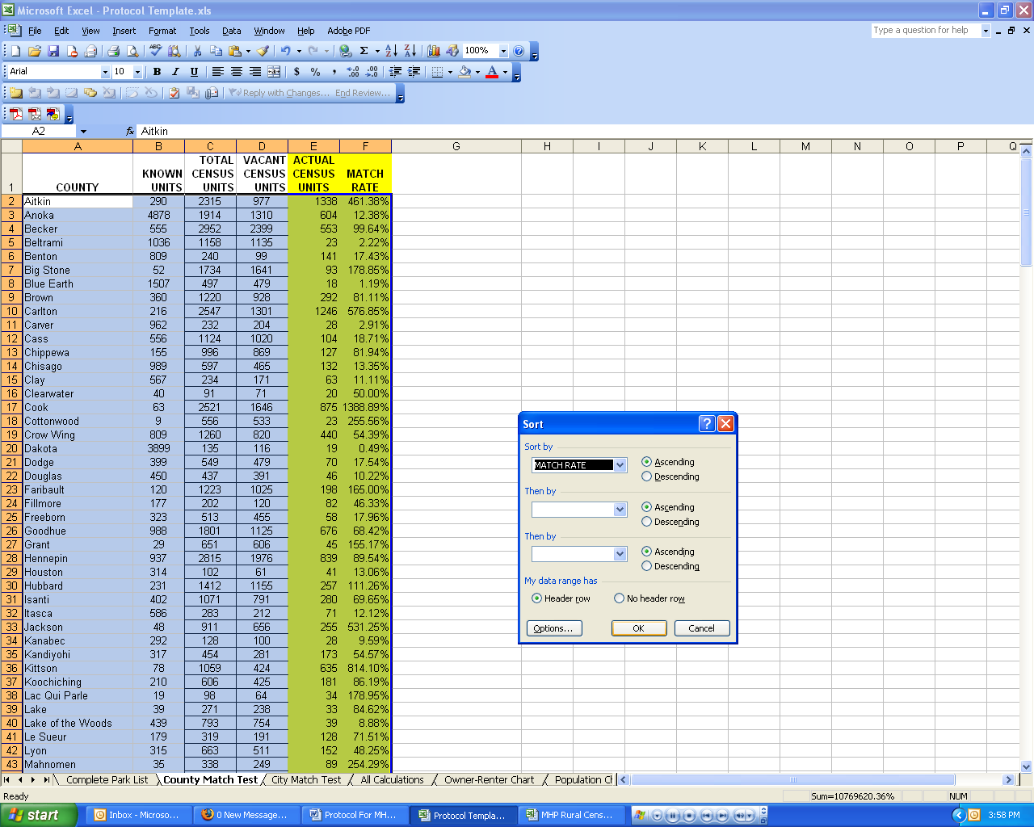

9) Copy those counties with match rates between 90% and 110% into column A of the “All Calculations” tab of your spreadsheet. Then copy columns B-F into columns B-F. Draw a line underneath the counties you have pasted.

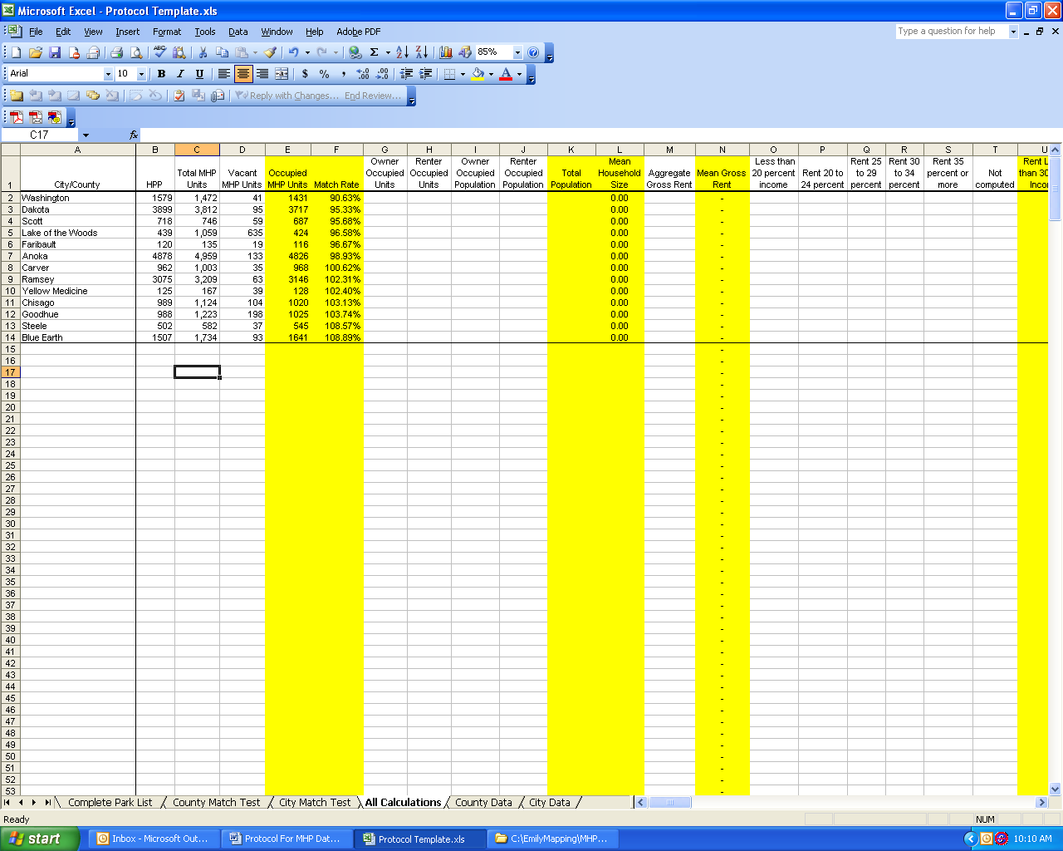

TEST CITY MATCHES:

1) Exclude all cities from your list that are located in the counties which you pasted into the “All Calculations” spreadsheet. If you do not exclude these cities, then you will double count certain areas, and thus throw off your data.

2) Repeat the steps above, using city data instead of county data. Note that the census refers to city as “Place.”

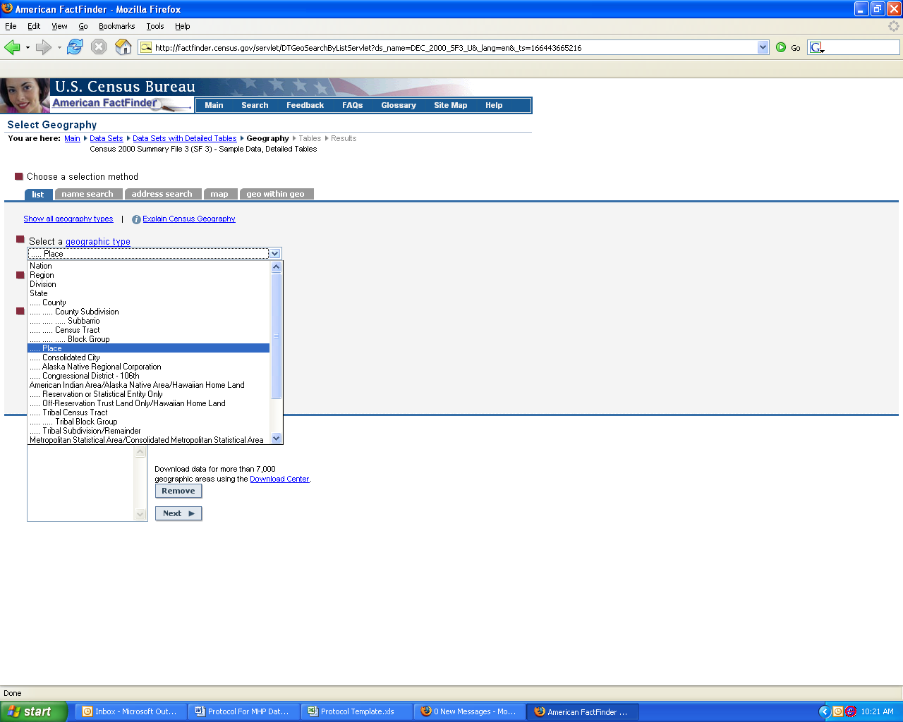

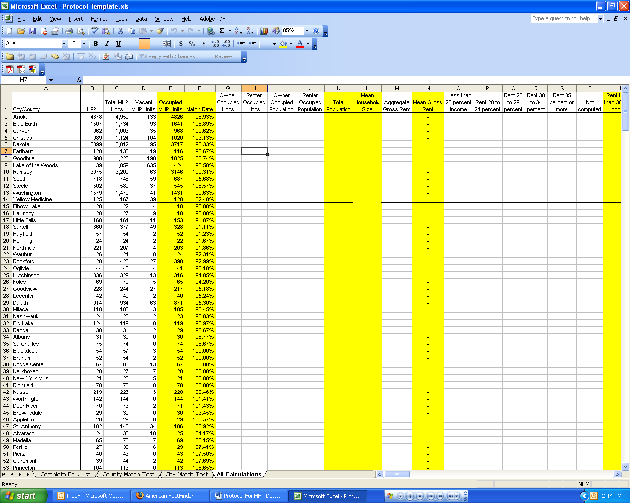

MANIPULATE CENSUS DATA:

1) Reopen the website for summary file 3. Select all of the counties and cities you have listed on the “All Calculations” spreadsheet. In other words, choose everything that had a match rate of between 90% and 100%. To expedite this process, sort your list alphabetically, keeping the cities and counties separate.

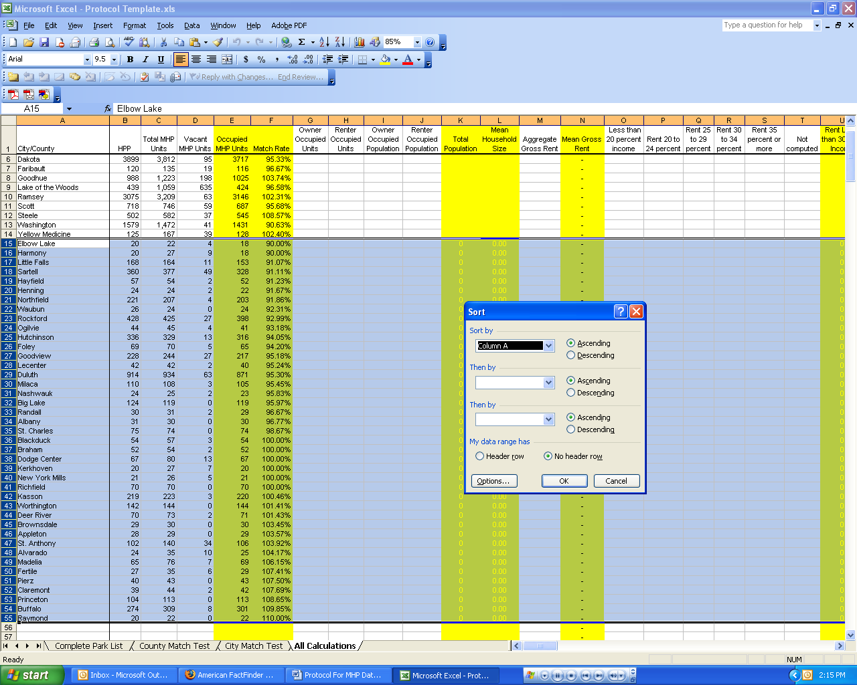

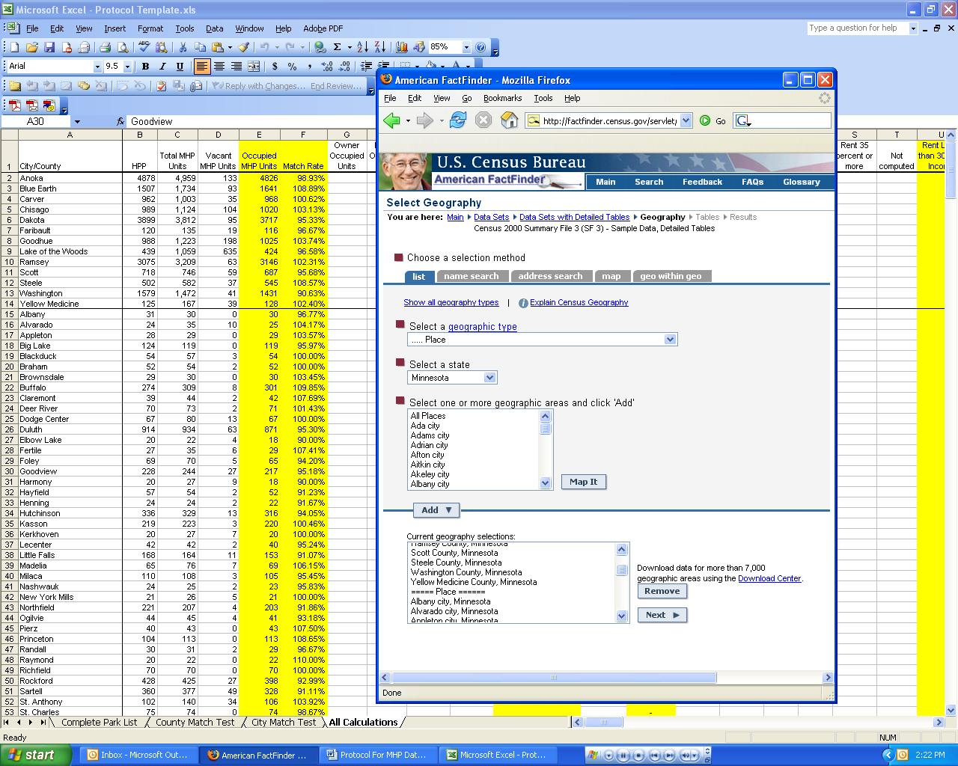

2) Select the following tables, and click “Add” then “Show Result”:

H30. Units in Structure
H31. Units in Structure for Vacant Housing Units
H32. Tenure by Units in Structure
H33. Total Population in Occupied Housing Units by Tenure by Units in
Structure
H66. Aggregate Gross Rent (Dollars) by Units in Structure
H72. Units in Structure by Gross Rent as a Percentage of Household Income in
1999
H79. Aggregate Value (Dollars) for all Owner-Occupied Housing Units by
Units in Structure
HCT3. Tenure by Household Size by Units in Structure
HCT4. Tenure by Age by Householder by Units in Structure
HCT6. Tenure by Year Structure Built by Units in Structure
HCT8. Tenure by Year Householder Moved into Unit by Units in Structure
HCT14. Aggregate Household Income in 1999 (Dollars) by Tenure by Age of Householder by Units in Structure
HCT30B. Units in Structure (Black Alone Householder)
HCT30C. Units in Structure (American Indian or Alaska Native Alone Householder)
HCT30D. Units in Structure (Asian Alone Householder)
HCT30E. Units in Structure (Native Hawaiian or Other Pacific Islander Alone Householder)
HCT30F. Units in Structure (Some Other Race Alone Householder)
HCT30G. Units in Structure (Two or More Races Householder)
HCT30H. Units in Structure (Hispanic Householder)
HCT30I. Units in Structure (White Alone, Not Hispanic Householder)

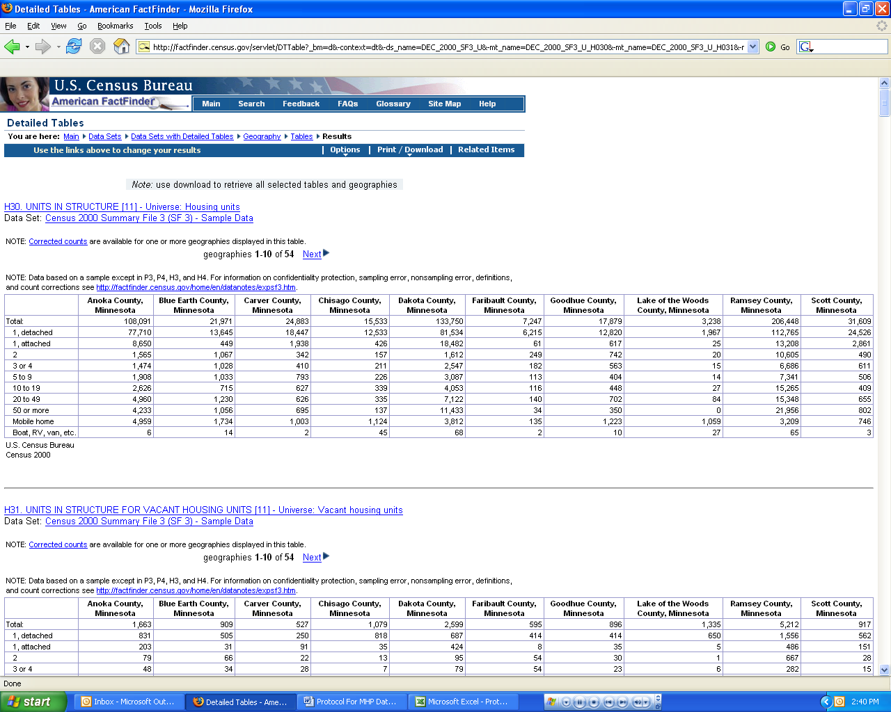

3) Go up to “Print/Download” tab and select “Download” form the drop-down menu.
Select the second option on the list, “Comma delimited (.csv) (transpose rows and columns)” and then click “Ok.” Your downloaded file will be called DTDownload.csv.

4) The next thing that you need to do is a ton of copying from the new DTDownload.csv spreadsheet into the “All Calculations” spreadsheet. You’ll notice that as you fill in the white columns, the yellow ones automatically calculate themselves.

CENSUS SUMMARY FILE | “DTDownload.csv” COLUMN | “All Calculations” COLUMN
H32 | L | G
H32 | W | H
H33 | L | I
H33 | W | J
H66 | H | M
H72 | AM | O
H72 | AN | P
H72 | AO | Q
H72 | AP | R
H72 | AQ | S
H72 | AR | T
H79 | H | W
HCT3 | J | Y
HCT3 | R | Z
HCT3 | Z | AA
HCT3 | AH | AB
HCT3 | AP | AC
HCT3 | AY | AD
HCT3 | BG | AE
HCT3 | BO | AF
HCT3 | BW | AG
HCT3 | CE | AH
HCT4 | J | AL
HCT4 | R | AM
HCT4 | Z | AN
HCT4 | AH | AO
HCT4 | AP | AP
HCT4 | AX | AQ
HCT4 | BF | AR
HCT4 | BO | AS
HCT4 | BW | AT
HCT4 | CE | AU
HCT4 | CM | AV
HCT4 | CU | AW
HCT4 | DC | AX
HCT4 | DK | AY
HCT6 | J | BC
HCT6 | R | BD
HCT6 | Z | BE
HCT6 | AH | BF
HCT6 | AP | BG
HCT6 | AX | BH
HCT6 | BF | BI
HCT6 | BN | BJ
HCT6 | BV | BK
HCT6 | CE | BL
HCT6 | CM | BM
HCT6 | CU | BN
HCT6 | DC | BO
HCT6 | DK | BP
HCT6 | DS | BQ
HCT6 | EA | BR
HCT6 | EI | BS
HCT6 | EQ | BT
HCT8 | J | BX
HCT8 | R | BY
HCT8 | Z | BZ
HCT8 | AH | CA
HCT8 | AP | CB
HCT8 | AX | CC
HCT8 | BG | CD
HCT8 | BO | CE
HCT8 | BW | CF
HCT8 | CE | CG
HCT8 | CM | CH
HCT8 | CU | CI
HCT14 | D | CM
HCT14 | L | CN
HCT14 | T | CO
HCT14 | AC | CP
HCT14 | AK | CQ
HCT14 | AS | CR
HCT14 | J | CS
HCT14 | R | CT
HCT14 | Z | CU
HCT14 | AI | CV
HCT14 | AQ | CW
HCT14 | AY | CX
HCT4 | D | CY
HCT4 | L | CZ
HCT4 | T | DA
HCT4 | AB | DB
HCT4 | AJ | DC
HCT4 | AR | DD
HCT4 | AZ | DE
HCT4 | BI | DF
HCT4 | BQ | DG
HCT4 | BY | DH
HCT4 | CG | DI
HCT4 | CO | DJ
HCT4 | CW | DK
HCT4 | DE | DL
HCT30B | B | DY
HCT30B | K | DZ
HCT30C | B | EB
HCT30C | K | EC
HCT30D | B | EE
HCT30D | K | EF
HCT30E | B | EH
HCT30E | K | EI
HCT30F | B | EK
HCT30F | K | EL
HCT30G | B | EN
HCT30G | K | EO
HCT30H | B | EQ
HCT30H | K | ER
HCT30I | B | ET
HCT30I | K | EU

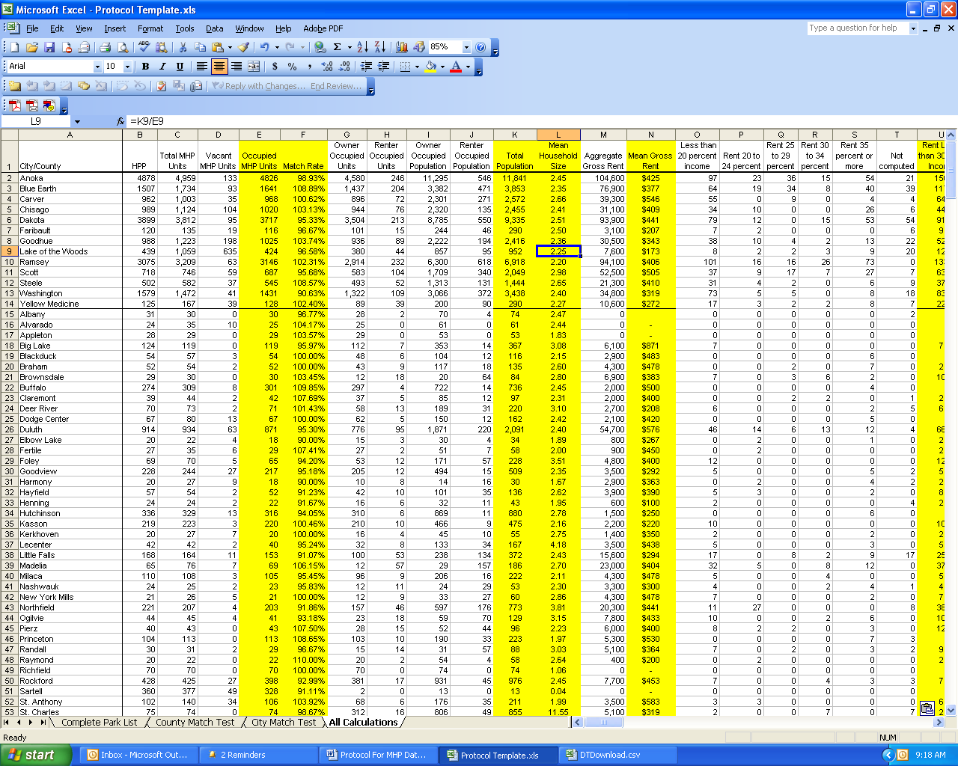

5) A few notes on what the data in the calculated rows means:

COLUMN | MEANING
E | This is one measure of how accurate your data is. The closer to exactly 100%, the better.
F | This tells you how many homes/households there are. Note that totaling this column would only tell you how many units there are in your selected data set, not in the entire state.
K | This tells you the total number of people living in manufactured home communities. Note that totaling this column would only tell you how many people there are in your selected data set, not in the entire state.
L | This tells you the average (mean) household size.
N | This tells you the average (mean) rent for those who rent both their home and the land it sits on. This is different than lot rent, and represents a relatively small portion of people living in manufactured home communities.
U | This tells you how many people are paying less than 30% of their total income towards rent. 30% is the standard cutoff that measures affordability. Again, note that this only applies to people who rent both their home and the land it sits on.
V | This tells you how many people are paying more than 30% of their total income towards rent. 30% is the standard cutoff that measures affordability. Again, note that this only applies to people who rent both their home and the land it sits on, and therefore represents a relatively small portion of people living in manufactured home communities.
X | This represents the average (mean) value of the homes themselves. Note that this is the homeowners own estimate of how much the home would sell for if it were for sale.
AI | This tells you how many households have only one occupant.
AJ | This tells you how many households have two occupants. If these occupants are related, then this falls under the census definition of “family housing.” Unfortunately, the census data does not give you a way to determine if people are related.
AK | This tells you how many households have three of more occupants. If these occupants are related, then this falls under the census definition of “family housing.” Unfortunately, the census data does not give you a way to determine if people are related.
AZ | This tells you how many heads of households are under age 35. Note that this unfortunately does not tell you the total number of people living in the house in that age range.
BA | This tells you how many heads of households are between the ages of 35 and 55. Note that this unfortunately does not tell you the total number of people living in the house in that age range.
BB | This tells you how many heads of households are aged 55 and older. This is generally considered the cutoff for senior citizens. Note that this unfortunately does not tell you the total number of people living in the house in that age range.
BU | This tells you how many homes are less than 10 years old.
BV | This tells you how many homes are between 10 and 20 years old. Many parks will not accept homes that are over 10 years old.
BW | This tells you how many homes are more than 20 years old. Many parks will not accept homes that are over 10 years old.
CJ | This tells you that the current occupant of the home has lived there for less than five years. HUD’s study “Is Manufactured Housing a Good Alternative for Low Income Families?” found that, despite stereotypes, the average tenure for those living in manufactured housing is longer than for those living in rental housing.
CK | This tells you that the current occupant of the home has lived there for between 5 and 10 years. HUD’s study “Is Manufactured Housing a Good Alternative for Low Income Families?” found that, despite stereotypes, the average tenure for those living in manufactured housing is longer than for those living in rental housing.
CL | This tells you that the current occupant of the home has lived there for more than ten years. HUD’s study “Is Manufactured Housing a Good Alternative for Low Income Families?” found that, despite stereotypes, the average tenure for those living in manufactured housing is longer than for those living in rental housing.
DM | This tells you how many heads of households for ALL housing types are under age 35. This data is only calculated so that we will be able to compare mean income levels.
DN | This tells you how many heads of households for ALL housing types are between the ages of 35 and 65. This data is only calculated so that we will be able to compare mean income levels.
DO | This tells you how many heads of households for ALL housing types are aged 65 and older. This data is only calculated so that we will be able to compare mean income levels.
DP | This tells you how many heads of households for manufactured housing are under age 35.
DQ | This tells you how many heads of households for manufactured housing are between the ages of 35 and 65. Note that this is a different age division than above.
DR | This tells you how many heads of households for manufactured housing are aged 65 and older. Note that this is a different age division than above.
DS | This tells you the average (mean) income for ALL housing types that are headed by householders under age 35.
DT | This tells you the average (mean) income for ALL housing types that are headed by householders between the ages of 35 and 65.
DU | This tells you the average (mean) income for ALL housing types that are headed by householders aged 65 and older.
DV | This tells you the average (mean) income for manufactured housing that is headed by householders under age 35.
DW | This tells you the average (mean) income for manufactured housing that is headed by householders between the ages of 35 and 65.
DX | This tells you the average (mean) income for manufactured housing that is headed by householders aged 65 and older.
EA | This calculates the number of African-American people living in housing types beside manufactured housing. The purpose of this calculation is so that it is possible to create a pie chart showing what percentage of Asian-American people live in manufactured housing.
ED | This calculates the number of African-American people living in housing types beside manufactured housing. The purpose of this calculation is so that it is possible to create a pie chart showing what percentage of Native-American people live in manufactured housing.
EG | This calculates the number of Asian-American people living in housing types beside manufactured housing. The purpose of this calculation is so that it is possible to create a pie chart showing what percentage of Asian-American people live in manufactured housing.
EJ | This calculates the number of Pacific-Islanders living in housing types beside manufactured housing. The purpose of this calculation is so that it is possible to create a pie chart showing what percentage of the Pacific-Islander population lives in manufactured housing.
EM | This calculates the number of “other” people living in housing types beside manufactured housing. The purpose of this calculation is so that it is possible to create a pie chart showing what percentage of the “other” people live in manufactured housing. This is a self-selecting census category, presumably meaning “none of the above.”
EP | This calculates the number of multiracial people living in housing types beside manufactured housing. The purpose of this calculation is so that it is possible to create a pie chart showing what percentage of multiracial people live in manufactured housing.
ES | This calculates the number of Latino (Hispanic) people living in housing types beside manufactured housing. The purpose of this calculation is so that it is possible to create a pie chart showing what percentage of Latino people live in manufactured housing.
EV | This calculates the number of white people living in housing types beside manufactured housing. The purpose of this calculation is so that it is possible to create a pie chart showing what percentage of white people live in manufactured housing.
EW | This calculates the number of manufactured households headed by people of color. This is the sum of all of the categories besides “white.”

5) The template creates numerous charts for you.

MAKING YOUR DATA MORE SPECIFIC:

One way to make your data more specific is to divide it up into regions. Most housing finance agencies already have standard regional divisions, and the data is available on their websites. The regions tend to be divided along county lines.

1) The last column in the template says “Region.” The fastest way to figure this out is actually by hand. It is possible to do in Excel using “if” functions, but they are pretty complex functions and probably don’t save time in the long run. Once you’ve manually filled in all of the regions, it is relatively easy to figure out values for them.

2) Draw a line under row 100. Starting in row 101, type the name of each region in Column A. Note that doing this in rows 1-100 will mess up the chart calculations, so it important that you do this in row 101.

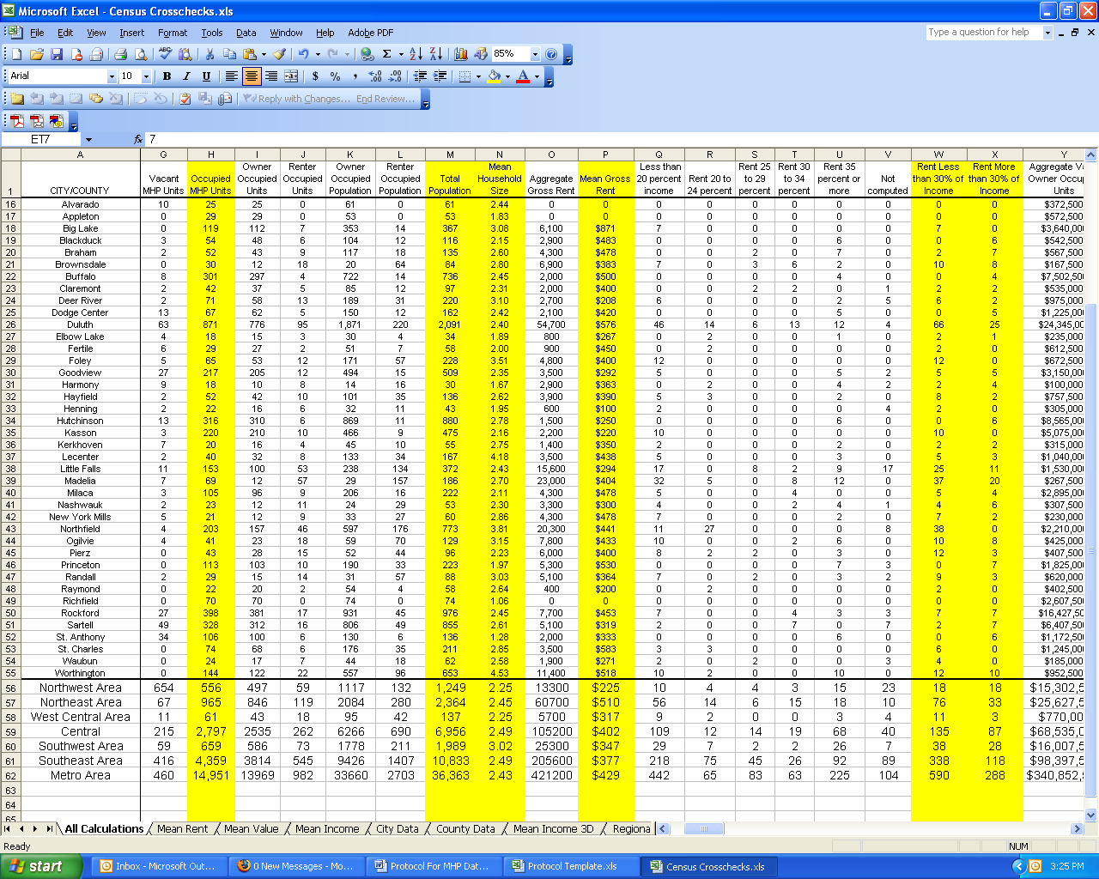

3) In all of the WHITE columns you’ll want to create a “sum if” function. Your function will look something like “=SUMIF($EX$2:$EX$100,"Region Name",?2:?100)” In place of Region Name though, you should type the name of the first region exactly how you typed it in column EX. In place of the question marks, type the letter of the column you are calculating.

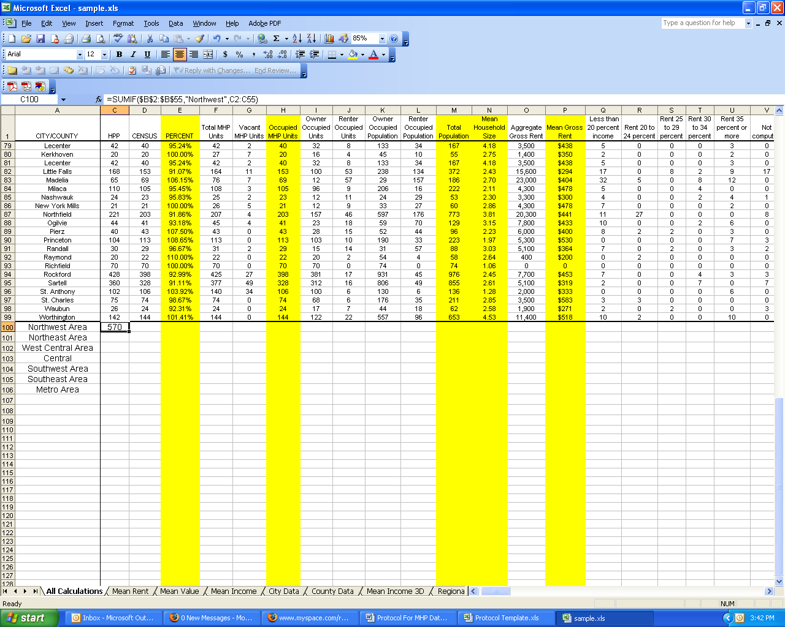

4) Once you have creating this function in cell B101, you can copy and paste it into all the white cells in row 101. To copy, highlight the cell (or cells) you want to copy and hit Ctrl and C simultaneously. To paste, highlight the cell (or cells) you want to paste into and hit Ctrl and V simultaneously. The letter of the column you are calculating will automatically change for you.

5) Repeat this step in each subsequent row until you have listed and created functions for all of your regions.

6) To fill in calculations for the yellow rows of each region, simply paste the function from row 100 of the same column.

